E9 - ws | listening – viewing comprehension: Cocoa | date:
- Explain the quote: Before you finish eating your breakfast in the morning, you’ve depended on more than half the world.
food from all over the world on our tables

- Enumerate some goods cocoa is used for. -> soap, chocolate, ice cream, moisturiser, gel

- Give five facts about the Dominican Republic and life there.
island in Caribbean, 10 mio inhabitants, average temp: 26°C, main language: Spanish
42% below poverty line, 2nd poorest country in Caribbean

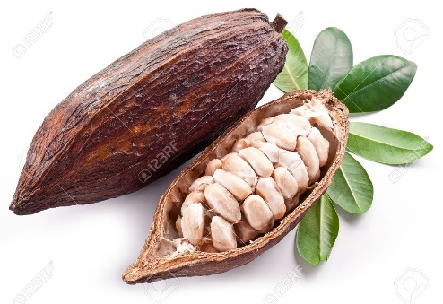
- Name these parts: cocoa pod, cocoa bean
- Write down how machete is pronounced: maschäti
- Explain what a cooperative is and why it’s an advantage to be part of it.
farmers join to help each other
one fermentation centre for all being part of Conocado

- Sketch (= describe shortly) the way from cocoa pod to chocolate.
cocoa pod -> split open -> beans -> fermentation ->chocolate flavour, kills germs -> drying -> sold to factories in Europe -> processed into…

- Name the three different products into which the cocoa beans are processed.
liquid chocolate, cocoa powder, cocoa butter
- How many chocolate bars are eaten in the UK in one year? 660 000 tons
How much is spent on chocolate in the UK per year? 4 billion pounds
- Which intention drives traders and manufacturers and why are they more powerful than the farmers?
driven by profit, control demand

- Explain three ways Fairtrade has helped the farmers and their communities. Give examples of how these measures affected people directly.
minimum price -> planning, investing
premium -> supply of running water, refurbishment of schools, drainage system
training + education

water => showering at any time, not having to carry water around => being able to work/school
electricity => proper kitchen
knowledge about how to plant trees, how trading system works

