E9 - ws | listening – viewing comprehension: Cocoa | date:
- Explain the quote: Before you finish eating your breakfast in the morning, you’ve depended on more than half the world.

- Enumerate some goods cocoa is used for:

- Give five facts about the Dominican Republic and life there.

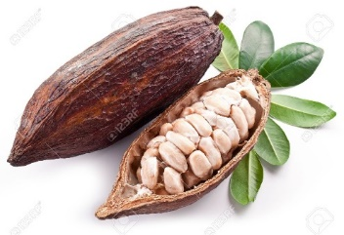
- Name these parts of the fruit:
- Write down how machete is pronounced:
- Explain what a cooperative is and why it’s an advantage to be part of it.

- Sketch (= describe shortly) the way from cocoa plant to chocolate.

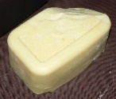
- Name the three different products into which the cocoa beans are processed.

- How many chocolate bars are eaten in the UK in one year?
How much is spent on chocolate in the UK per year?
- Which intention drives traders and manufacturers and why are they more powerful than the farmers?

- Explain four ways Fairtrade has helped the farmers and their communities.

