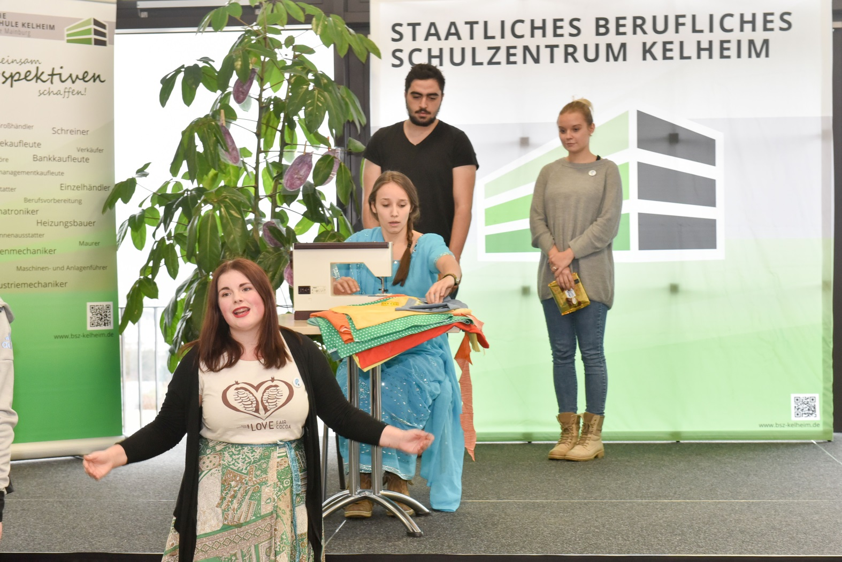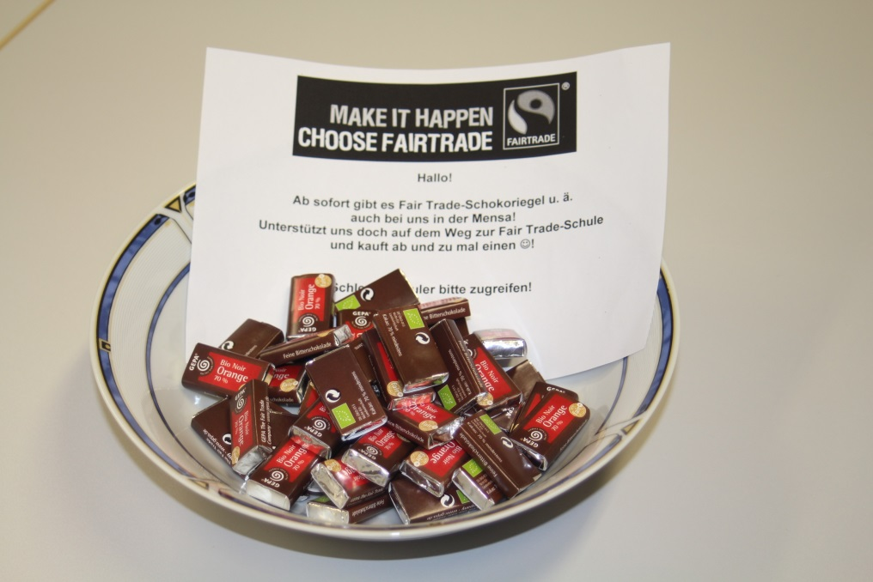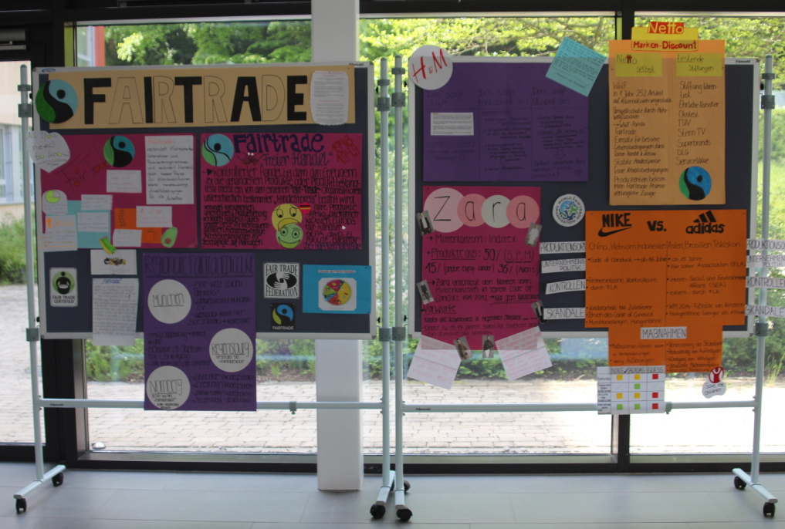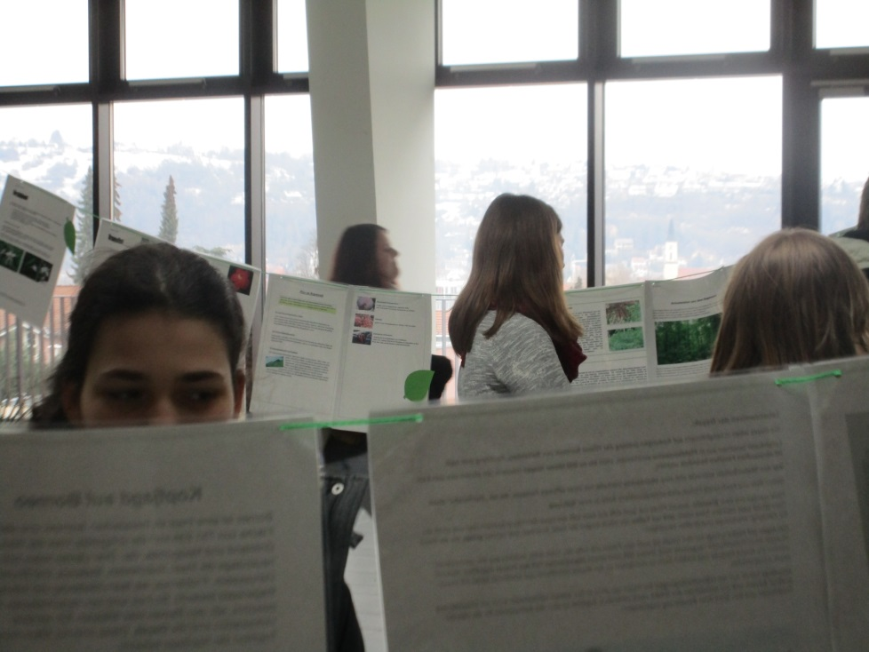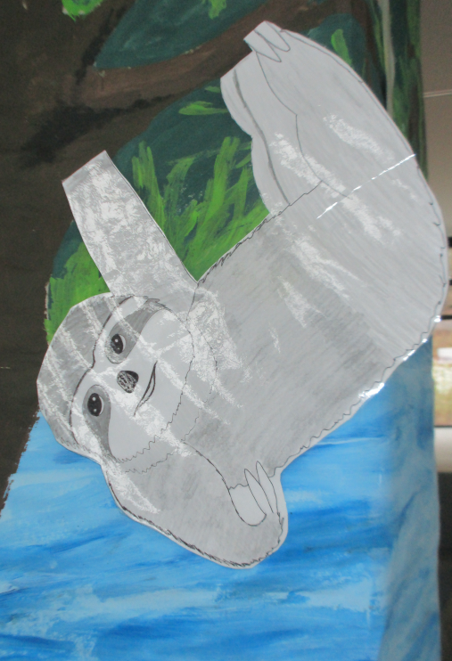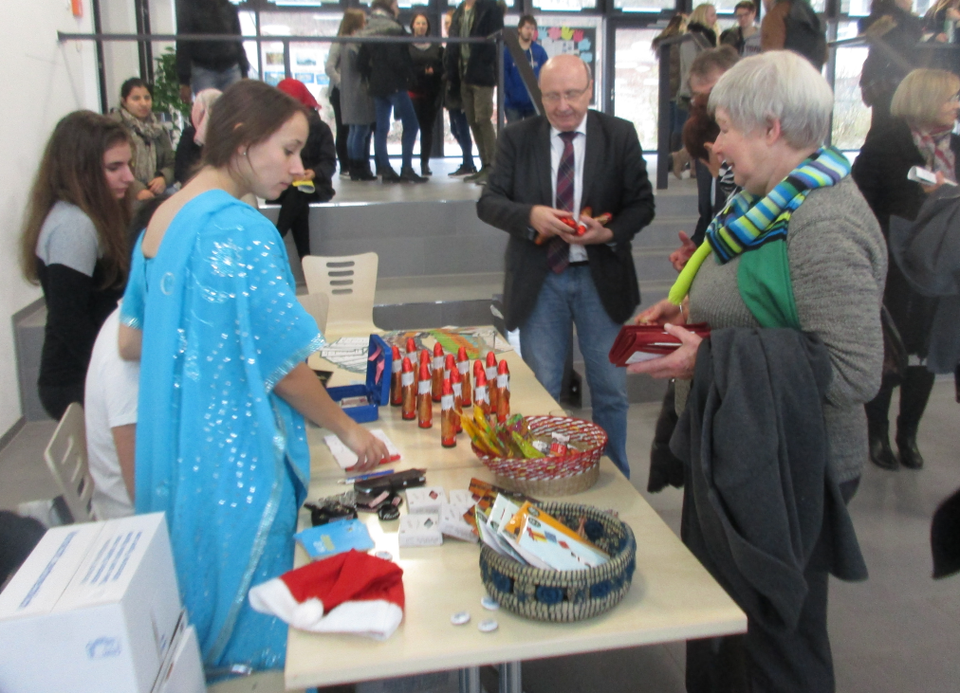 

**FAIR TRADE SONG**

**(Melodie von “Go down, Moses”)**

*When people work so hard all day – let their lives be good!*

*Poor farmers, children, women, men, let their lives be good!*

Come on, Rajif!

Cotton doesn´t grow itself! Give it some pesticides.

Not my fault, if you get ill!

*When people work so hard all day – let their lives be good!*

*Poor farmers, children, women, men, let their lives be good!*

Sit down, Ajitha!

Sit down and work for us! We want cheap T-Shirts!

So, hey, sit down and work!

*When people so work hard all day – let their lives be good!*

*Poor farmers, children, women, men, let their lives be good!*

Wake up, Juanito!

You don´t know how chocolate tastes?

Poor boy, but we know it

And we want more and more!

*When people work so hard all day – let their lives be good!*

*Poor farmers, children, women, men, let their lives be good!*

Let´s go, Rosita!

Coffee tastes so fine! We drink it every day,

But we don´t want to pay!

*When people work so hard all day – let their lives be good!*

*Poor farmers, children, women, men, let their lives be good!*

**Umfrage**

**„Fairer Kaffee“**

**Erarbeitung einer**

**Fair Trade - Rallye**

**Fair Trade im**

**Unterricht**

**Fair Trade-Team**

**Zusammenarbeit mit der SMV**

**Zusammenarbeit mit den Fair Trade-Städten Kelheim, Abensberg und Mainburg**

**Ausstellung „Regenwald“**

**Faire Produkte:**

**Lehrerzimmer**

**Kantine**

**Abschlussfeier der Berufsschule**

**Abiturfeier**

**Weihnachtsbasar**

**Valentinstag**

**Nikolaus**

**Kuchenverkauf**

BSZ Kelheim

**Fair Trade-Schule**

**seit Dezember 2016**